**User flows**

User flows tend to show a specific persona’s pathway through the design at hand. A set or series of task flows can be embedded within user flows, but unlike task flows, user flows include decision points wherein the persona’s journey to the desired goal can differ, based on decisions the persona need to make in interacting with the design.

Example: source https://uxdesign.cc/when-to-use-user-flows-guide-8b26ca9aa36a

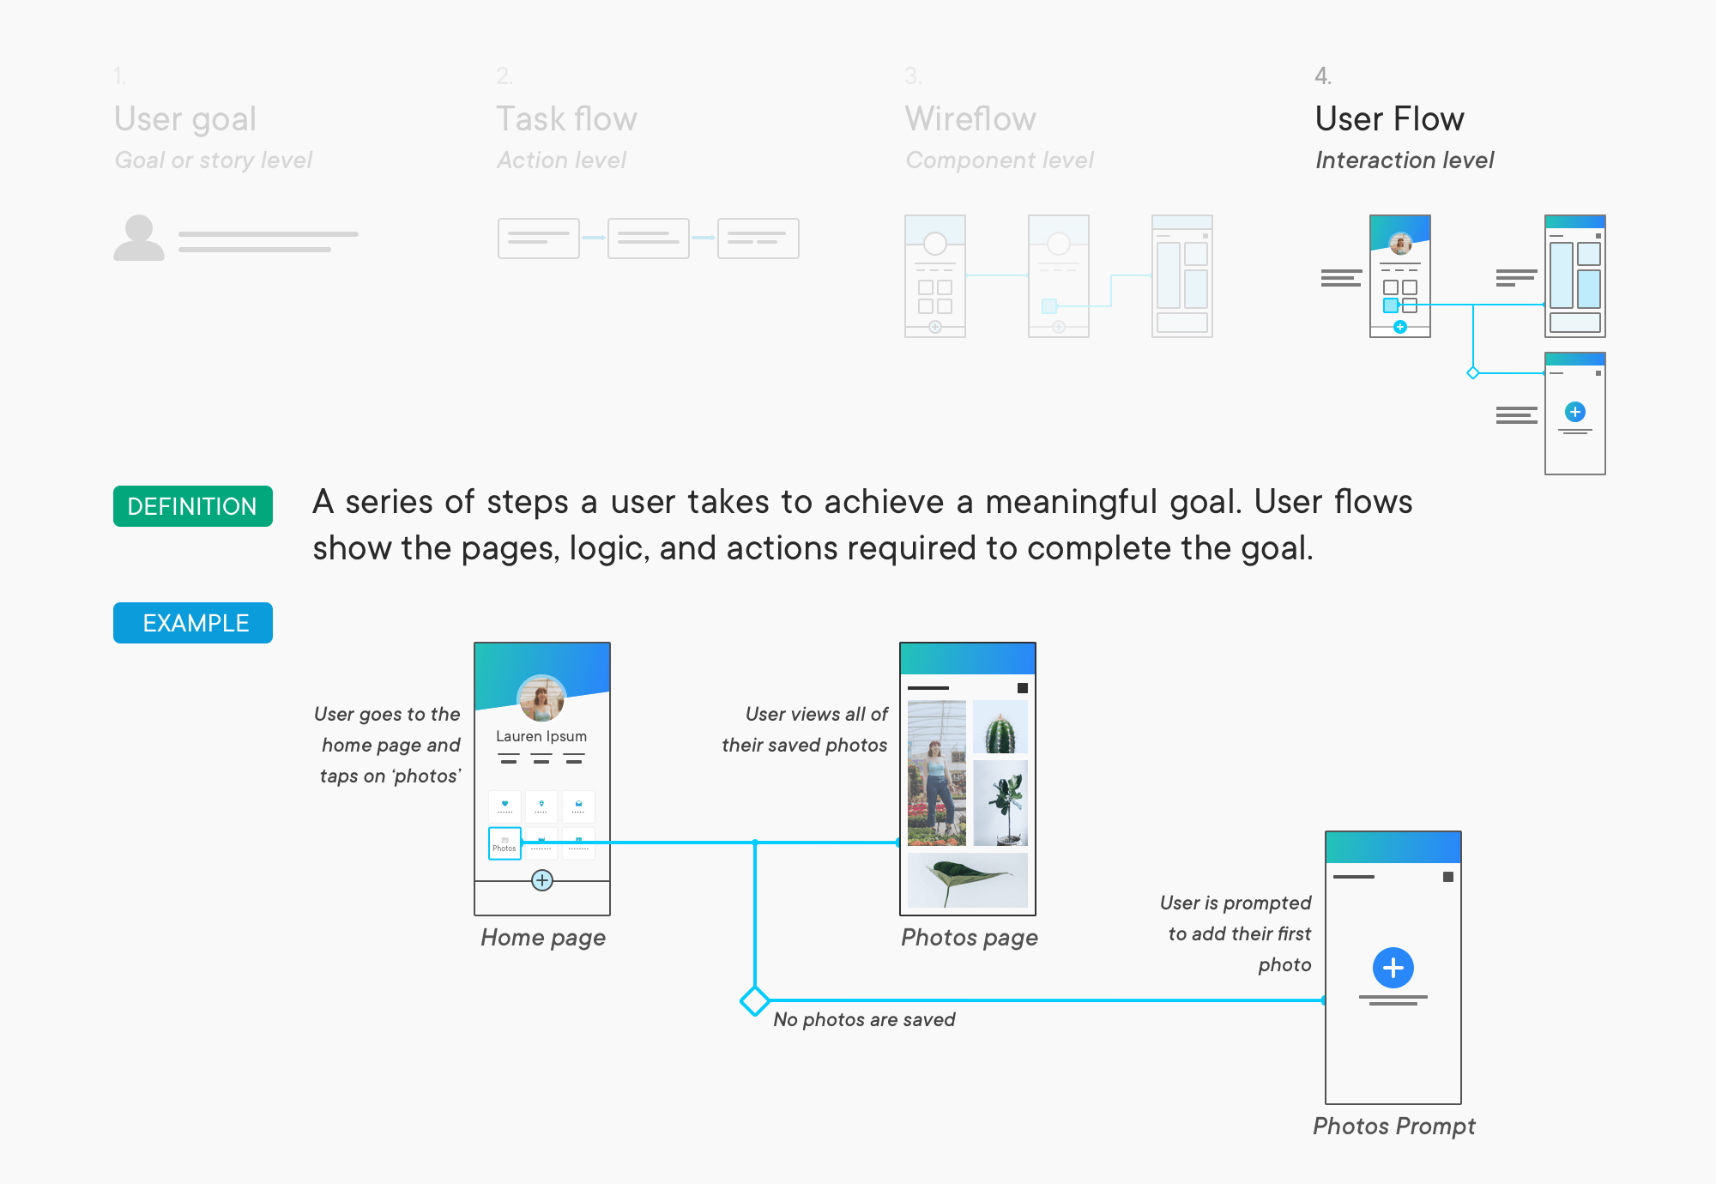

Reference: https://medium.com/erika-harano/ux-task-flows-versus-user-flows-as-demonstrated-by-pancakes-896e78a98026